

**UNIVERSITY OF KUALA LUMPUR**

**MALAYSIAN INSTITUTE OF INFORMATION TECHNOLOGY**

|  |  |  |  |
| --- | --- | --- | --- |
| **Name of Course** | Software Configuration Management (SCM) | **Course Code** | ISB42303 |
| **Lecturer** | | Ms. Nurul Sharaz Azmanuddin | |

|  |  |  |
| --- | --- | --- |
| **ID Number** | **Student Name** | |
| 52213116280 | MUHAMAD FAIZ BIN HISHAMMUDDIN | |
| 52213116286 | AFIQ IZZUDDIN BIN MOHAMAD BUKHAREE | |
| 52213116044 | SYED ZARUL ZAQUAN BIN SYED MUHAMAD ZULKIFLI | |
| 52213116292 | WAN MOHAMAD NAIMAN BIN WAN MAYU OTHMAN | |
| **Programme** | | BSE |
| **Submission Date** | | 16 May 2019 |

|  |  |
| --- | --- |
| **Assessment** | User Manual |

**1.0 Admin**

1. Admin click button “SHOP NOW” and login

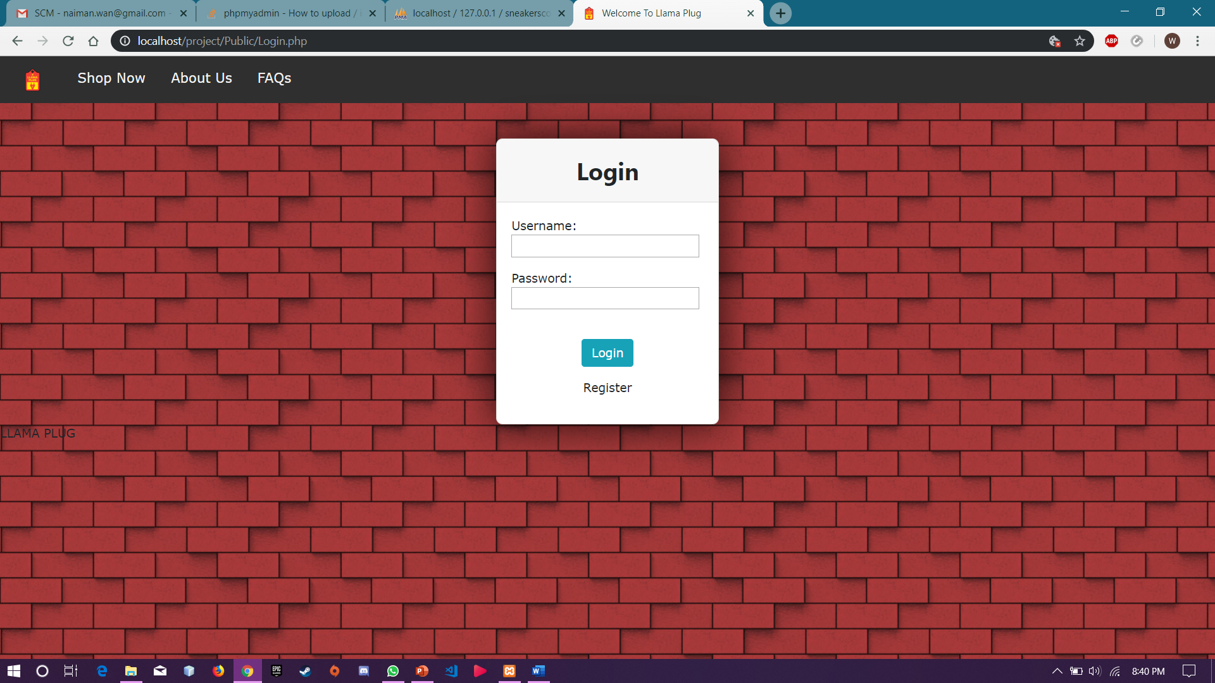

1. Admin click button “ADD PRODUCT”, fill information of the product and click button submit

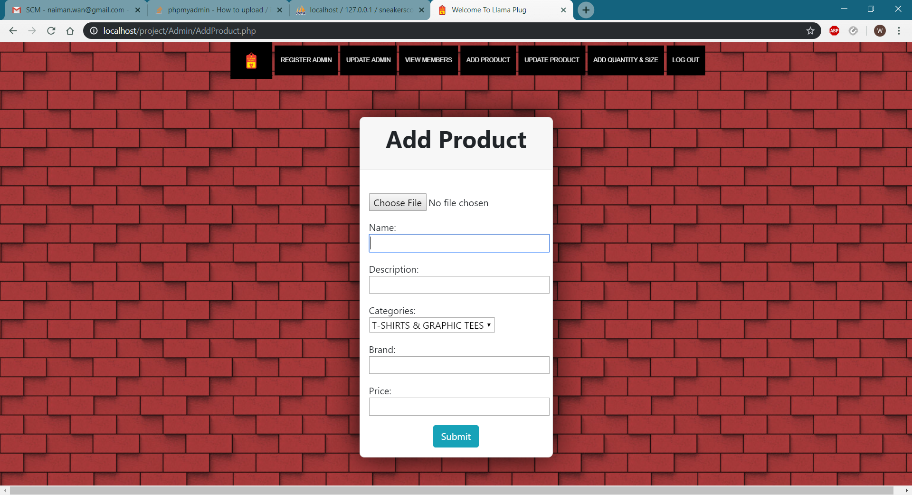

1. Admin click button “Update Product” and click button “Edit” on selected product.

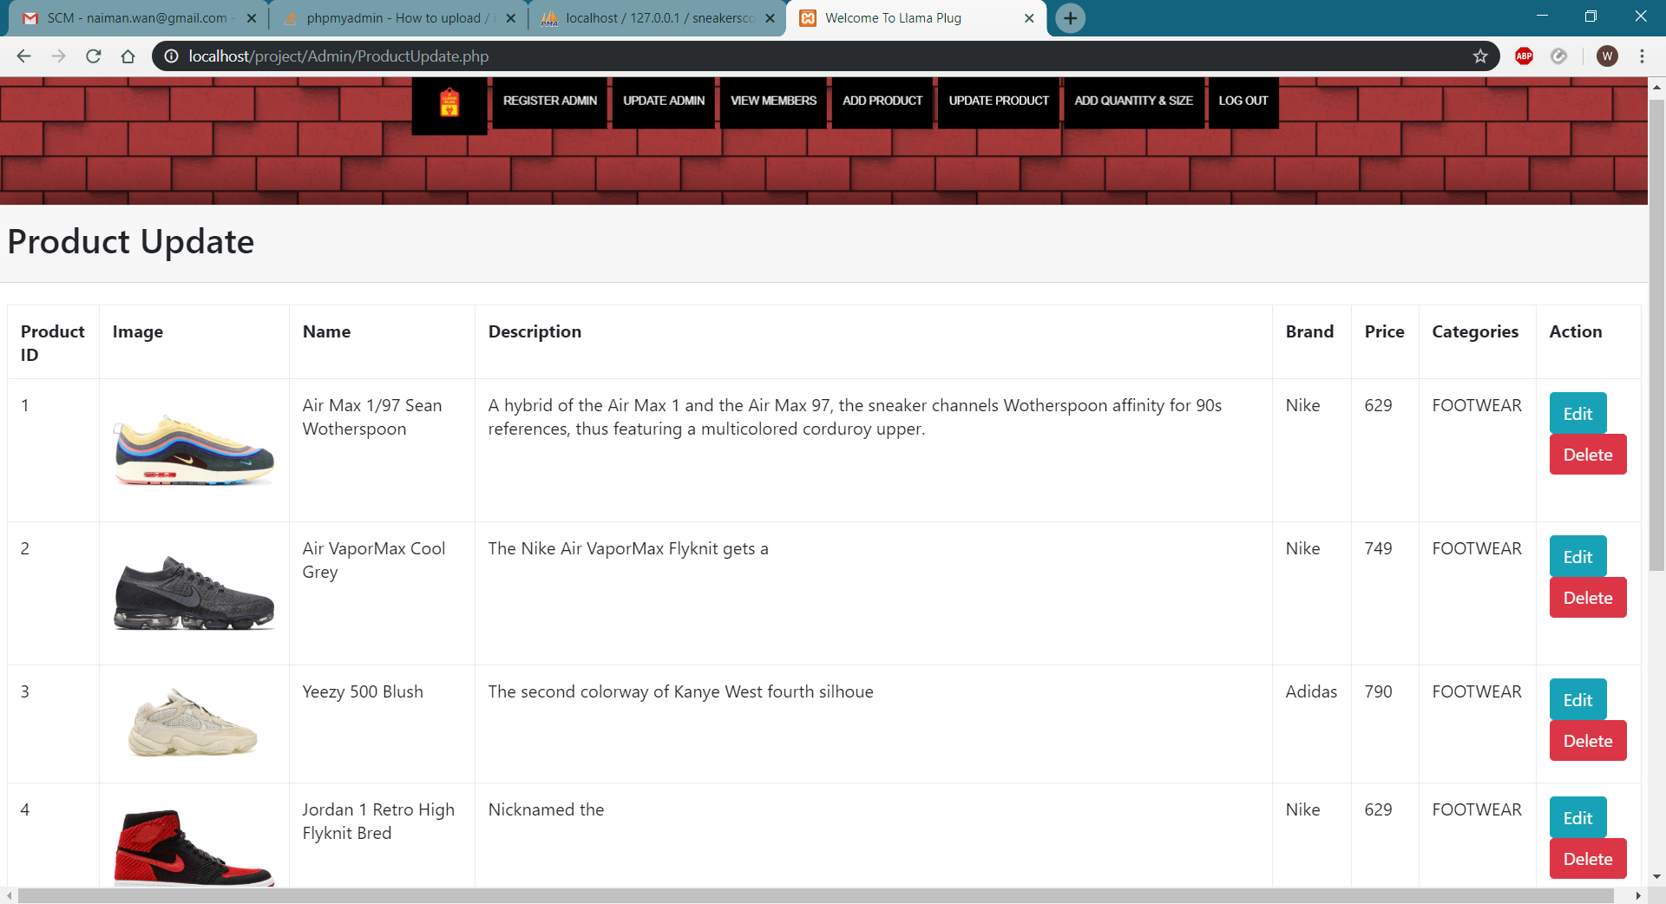

1. Admin fills the information that needed to be updated and click “Submit” button.

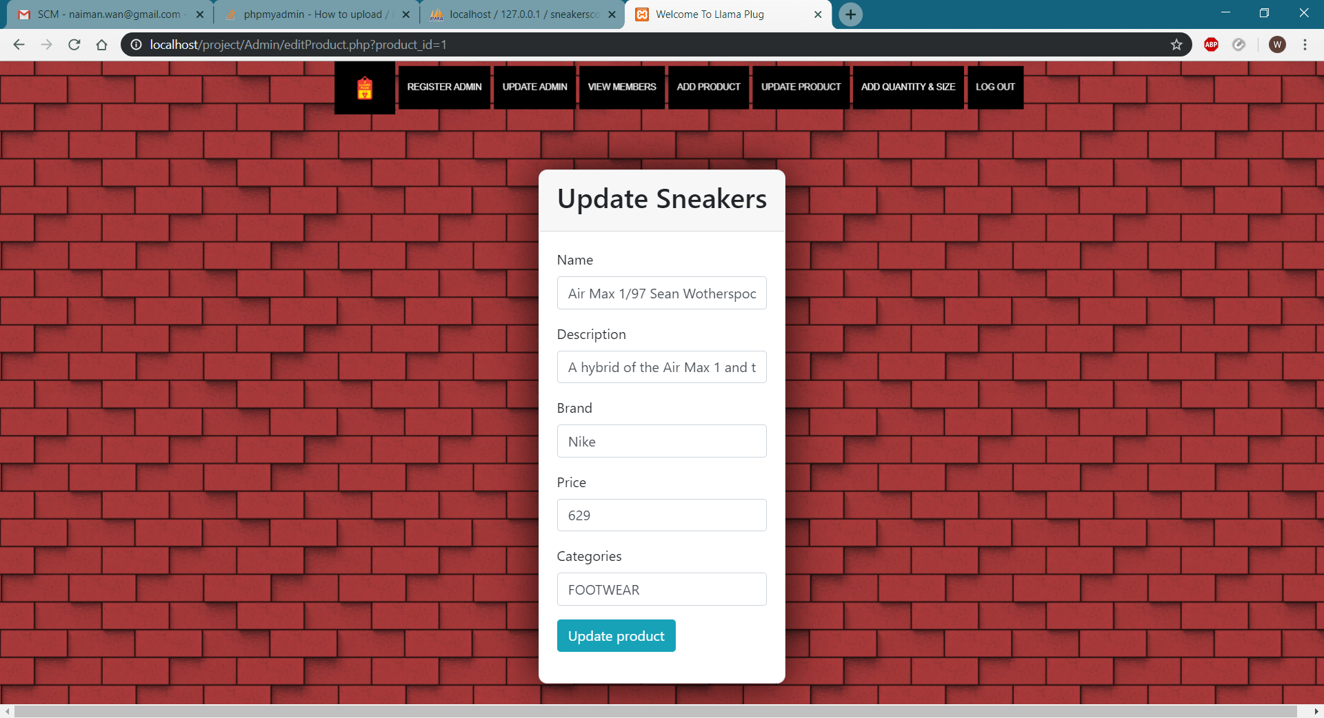

1. Admin click button “UPDATE ADMIN”, then click button “EDIT”.

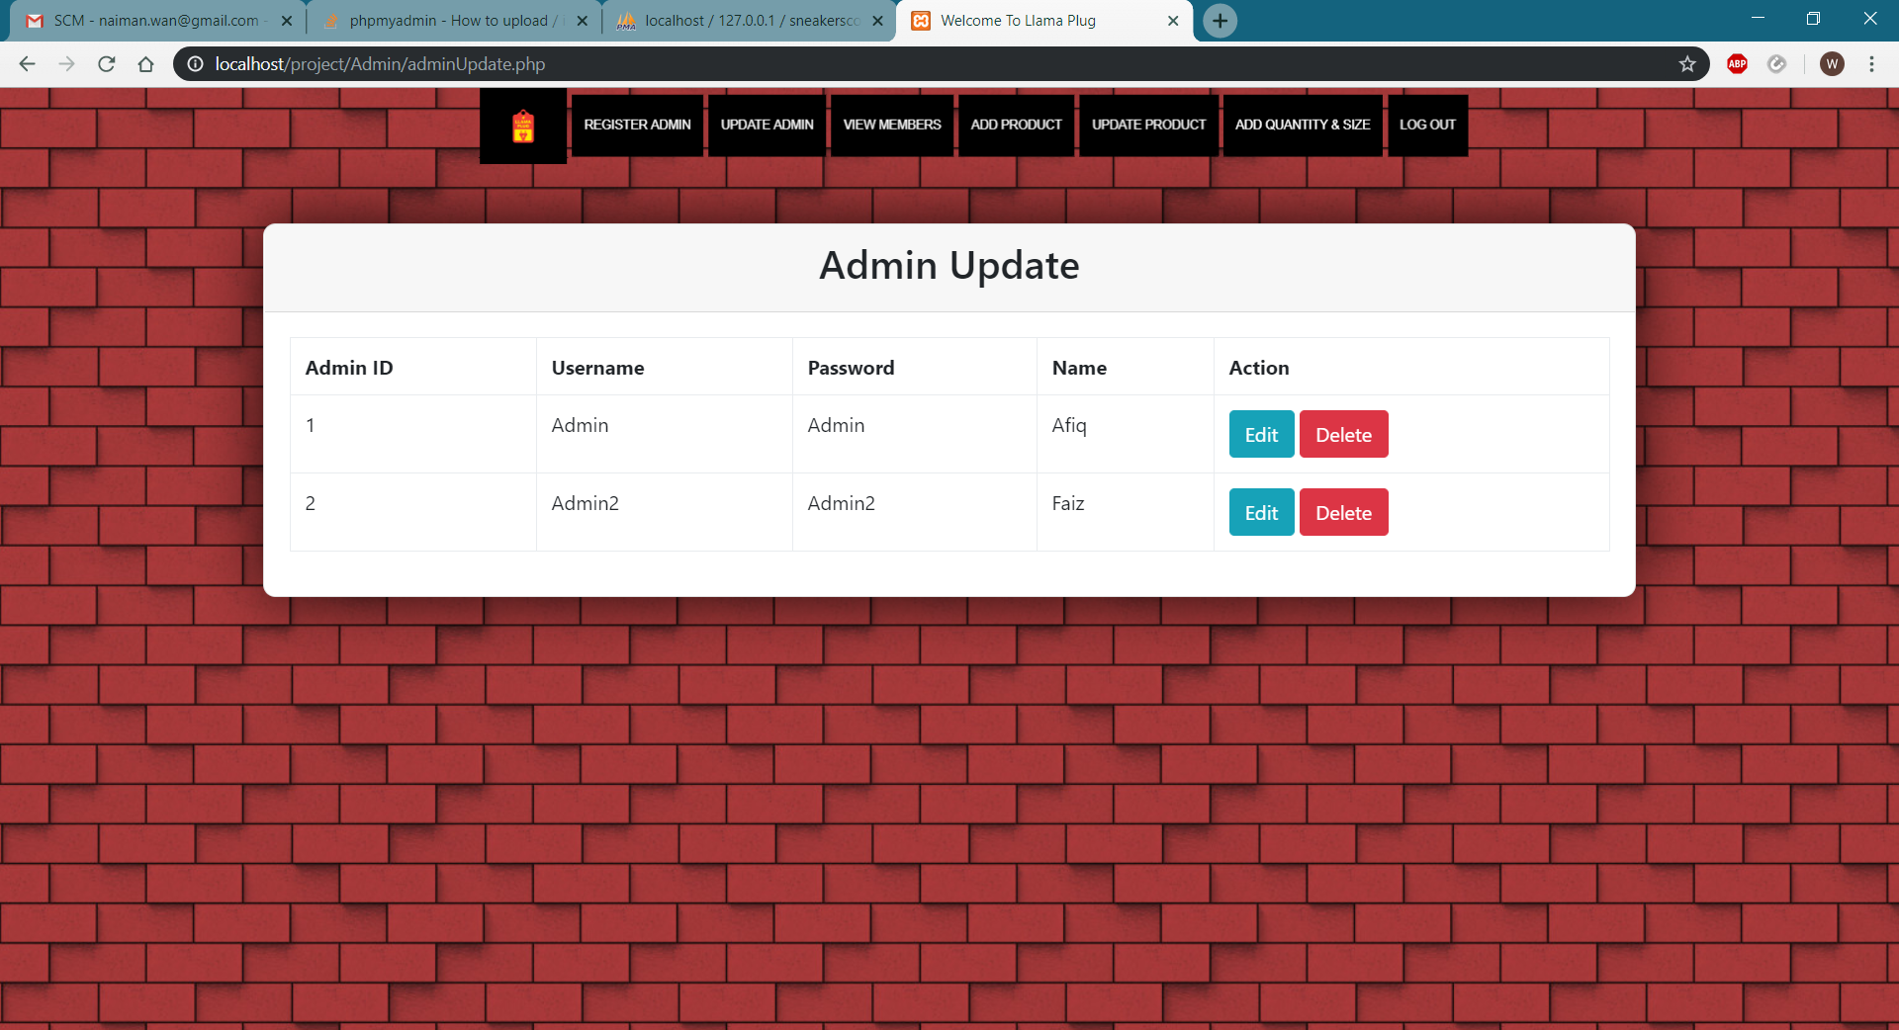

1. 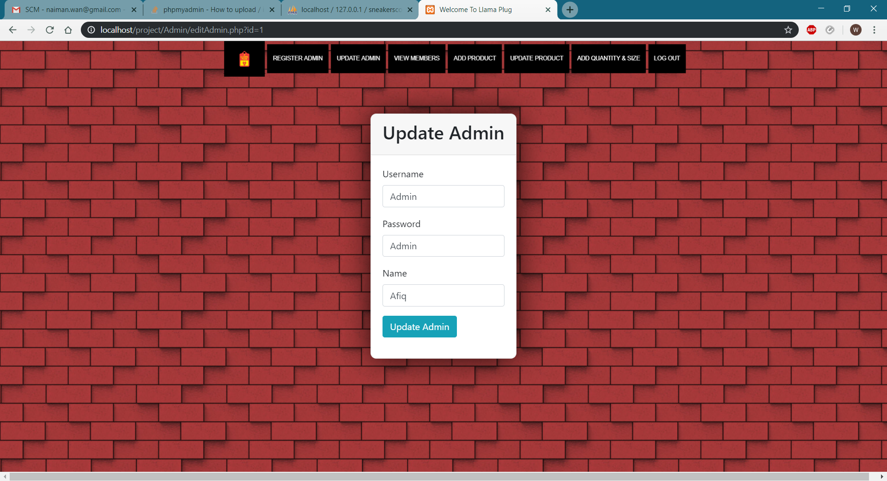Admin fills in the information that needed to be updated and click button “UPDATE ADMIN”.
2. Admin click button “VIEW MEMBERS” to view members user information.

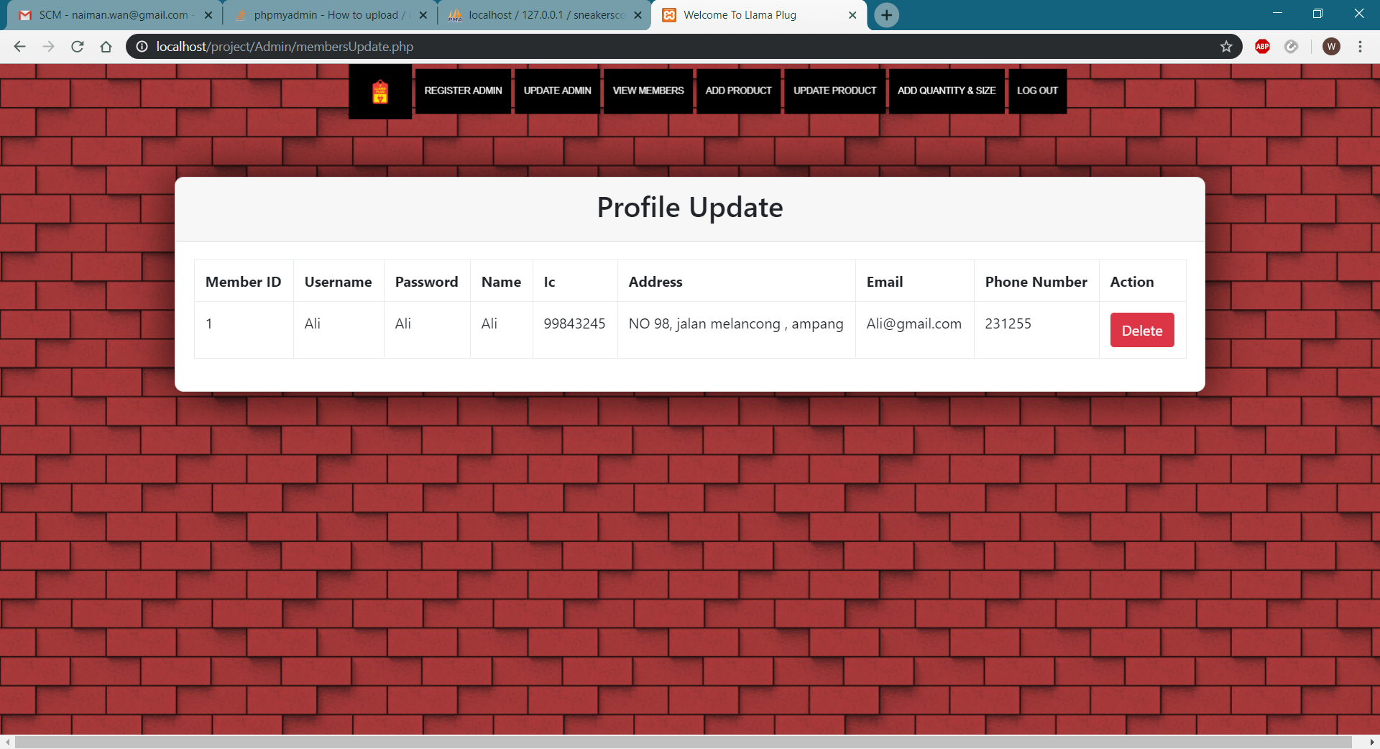

1. Admin click button “ADD QUANTITY AND SIZE” in the ADD QUANTITY AND SIZE page to make an update for quantity and size.

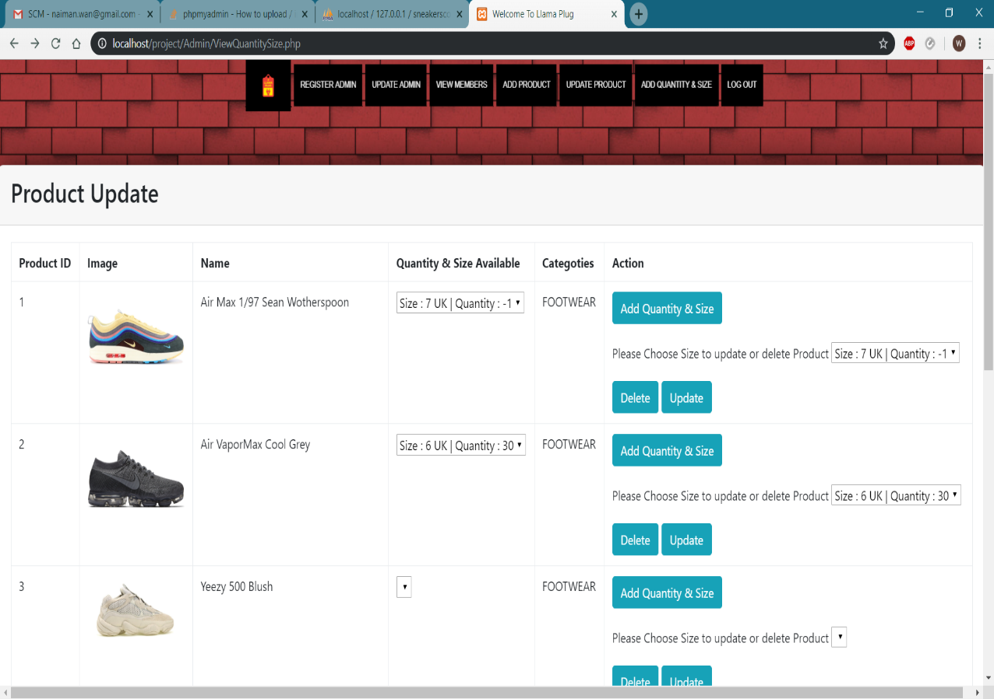

1. Admin click button “SUBMIT” to make an update.

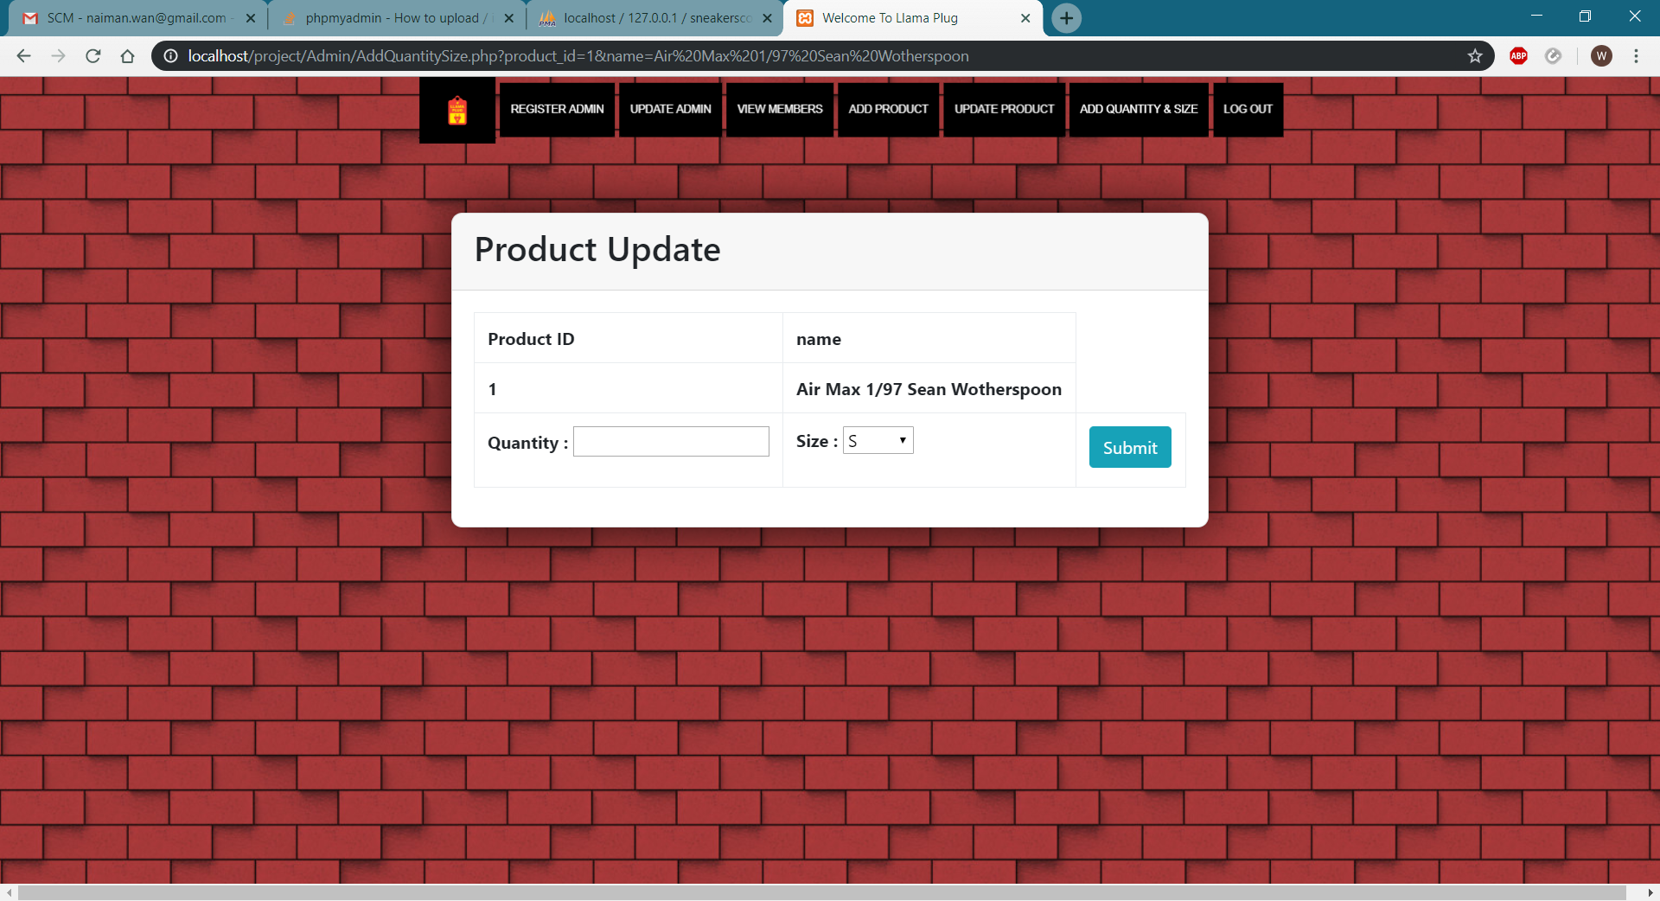

**Member**

1. Member Click button “SHOP NOW” and click button “REGISTER” after filling out the information required.

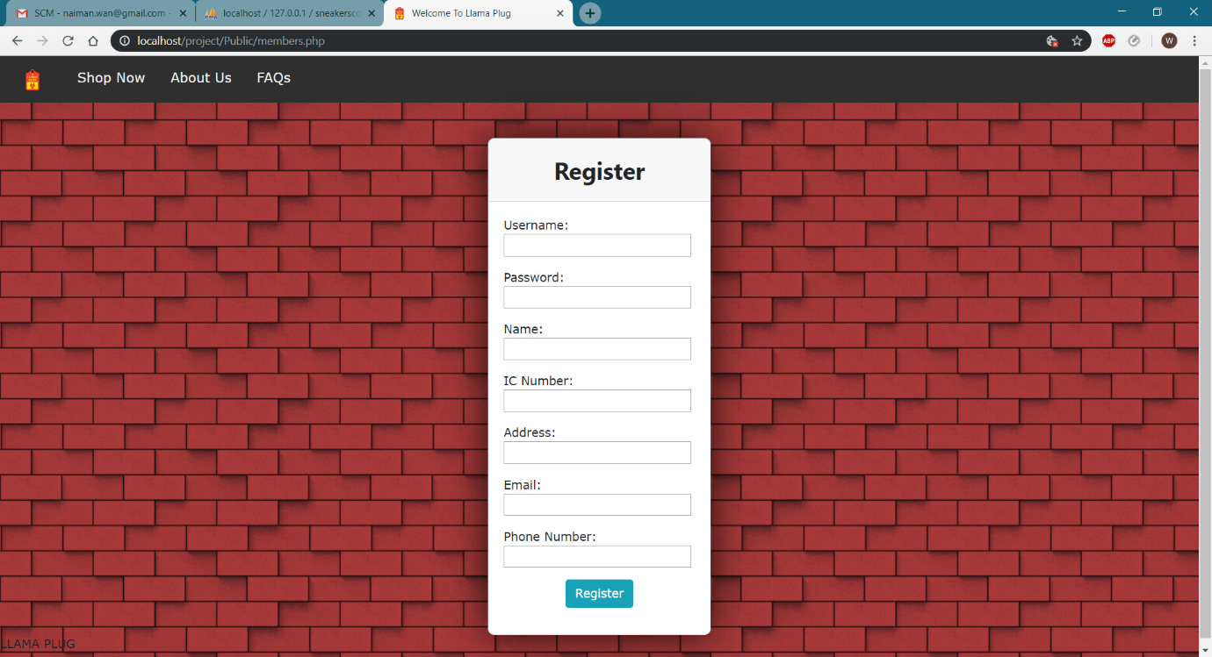

1. Member click button “Shop Now” and click button “Login” after filling the Username and Password.

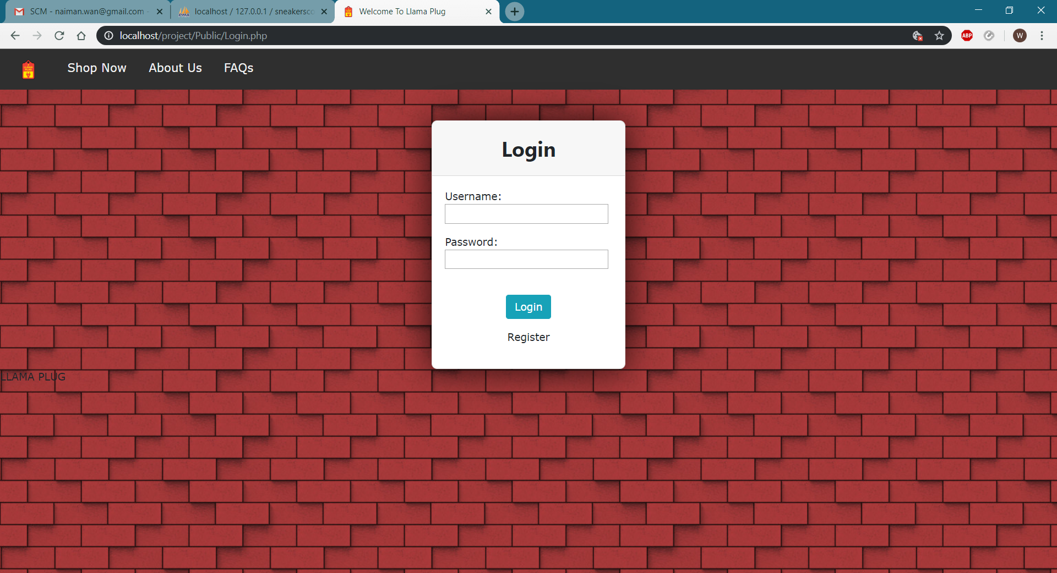

1. After member login, member click button “Shop Now” and then select the product to view the product.

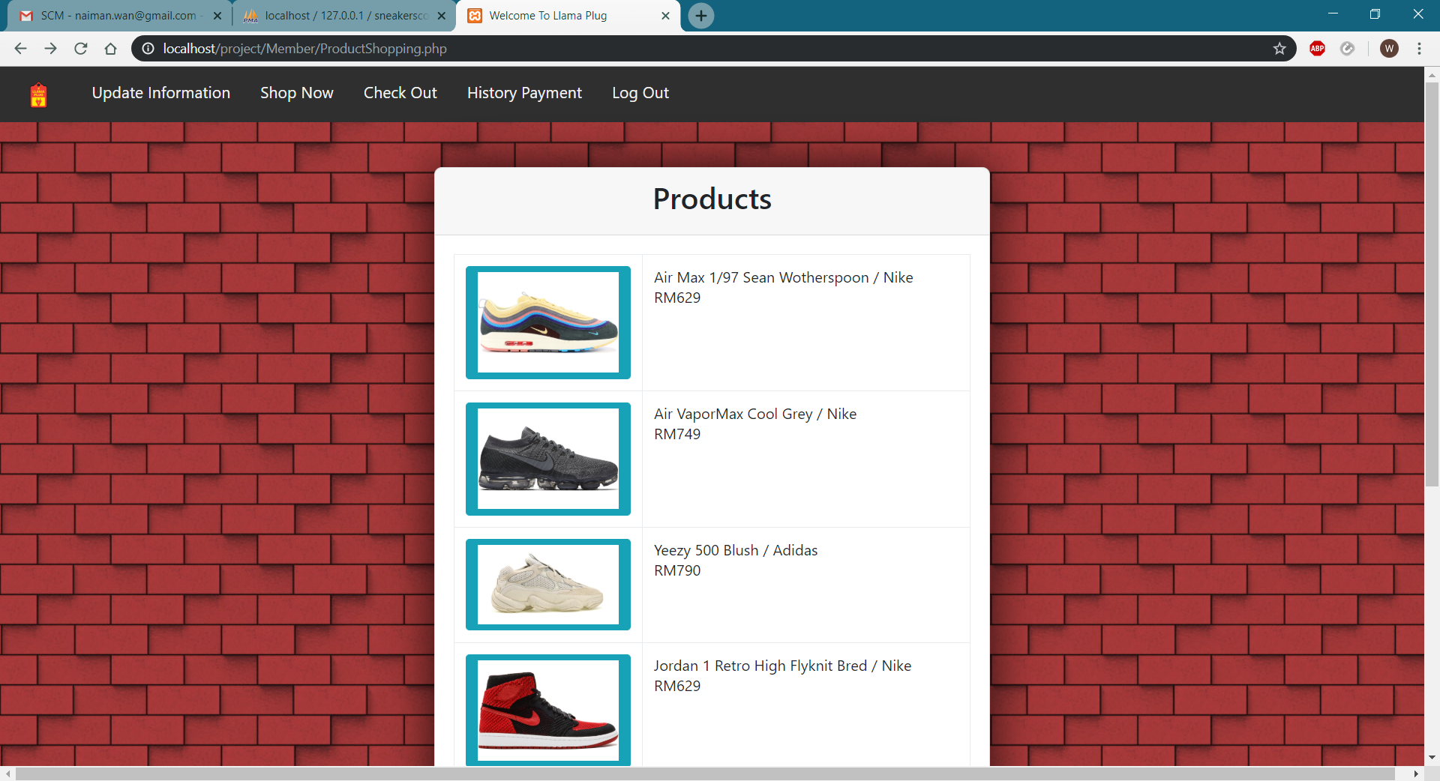

1. 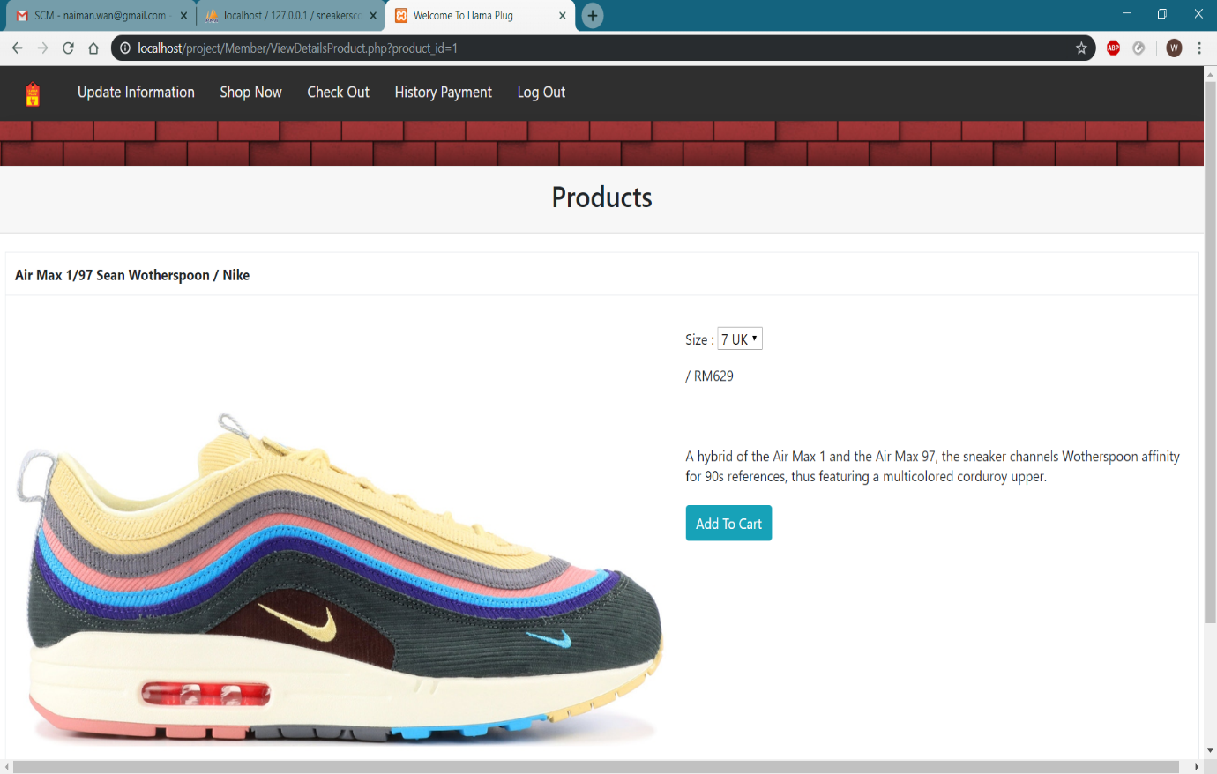After clicking the selected product, the page will direct the user to the product view page. Member can choose the size and click button “Add To Cart” if the user wanted to buy the product.
2. Member click button “Payment” if the member wanted to buy the product or click button “Delete” to remove the product from the cart. Member can also click the button “Check Out” on the top tab to view cart.

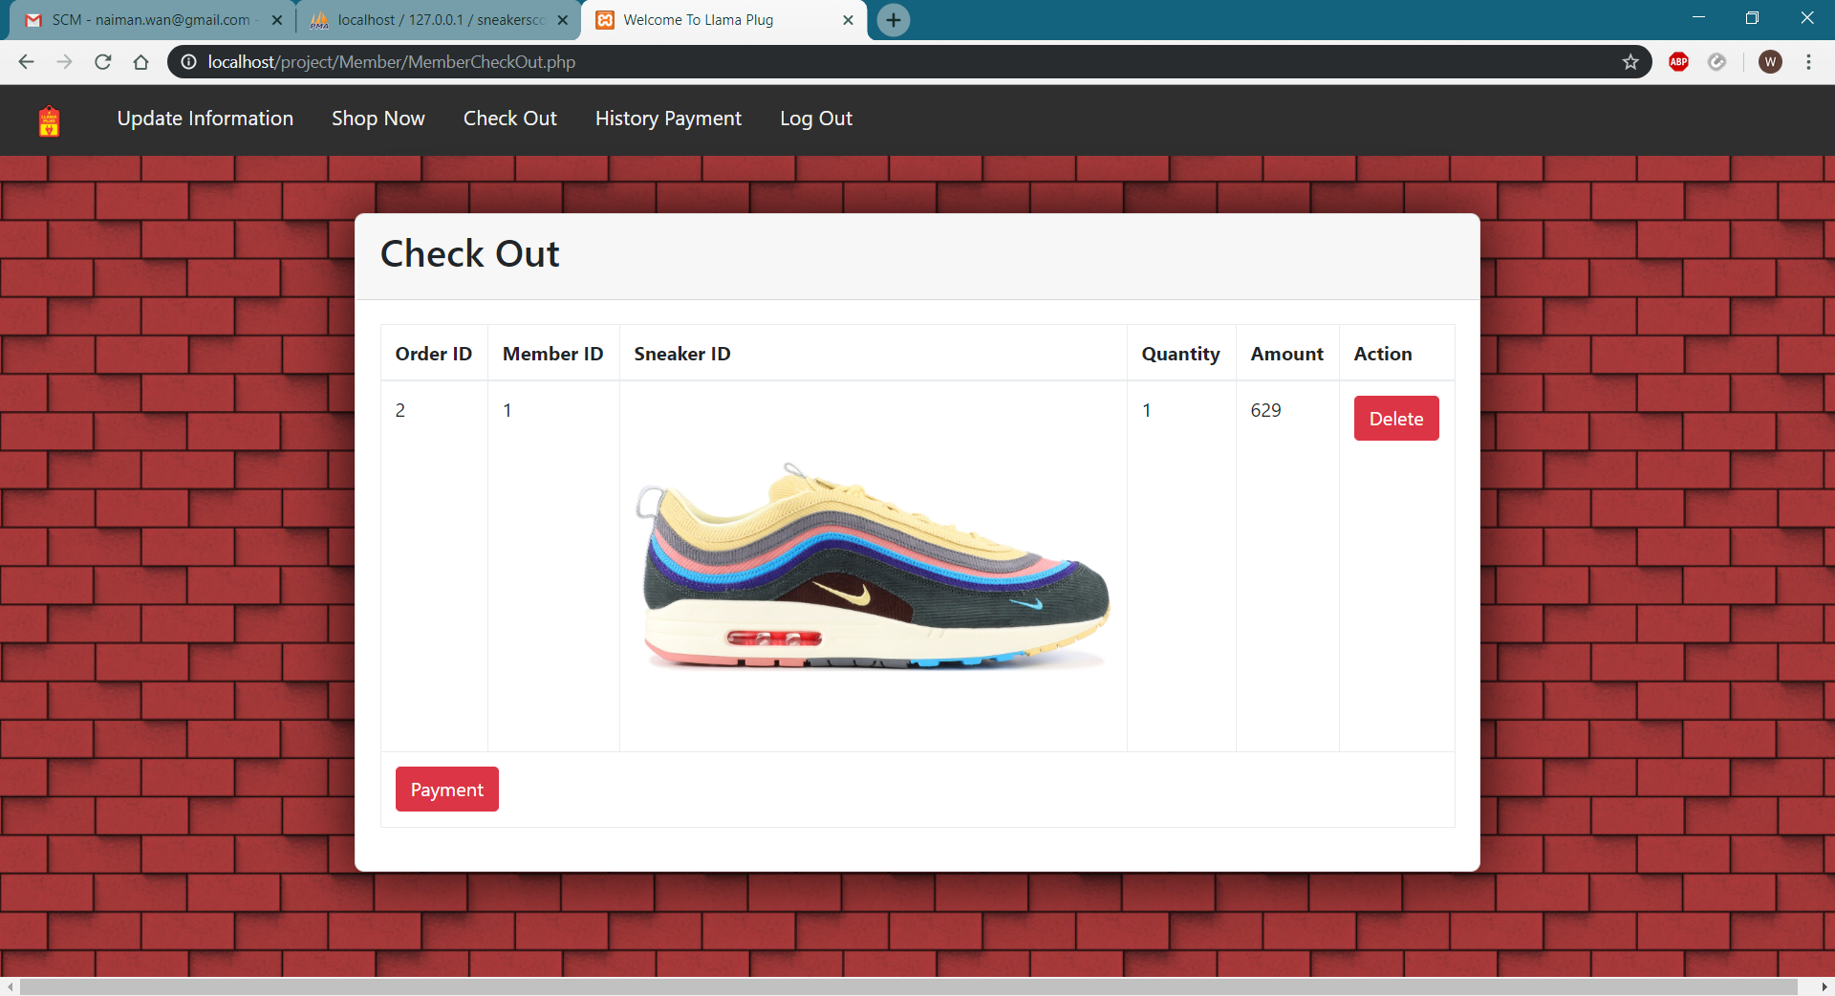

1. Member fill the payment details and click button “Submit” to confirm order and payment.

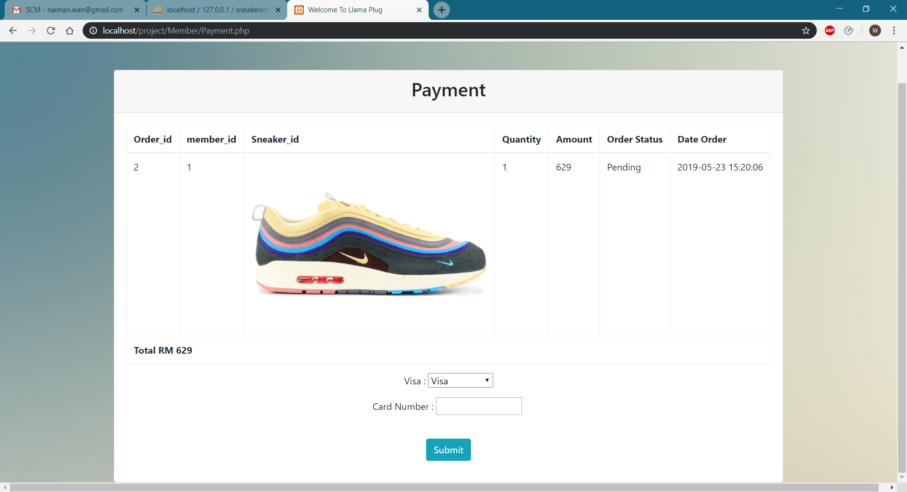

1. After member make a payment, member can click button “History Payment” to view the purchase product.

